The only issues I had while doing this workshop were the ball bouncing off objects that didn't appear there. This was solved by putting the regular collision code in an else statement instead of making it run all the time. For the level i made i wanted a single more difficult shot and modelled the level after a basketball throw.

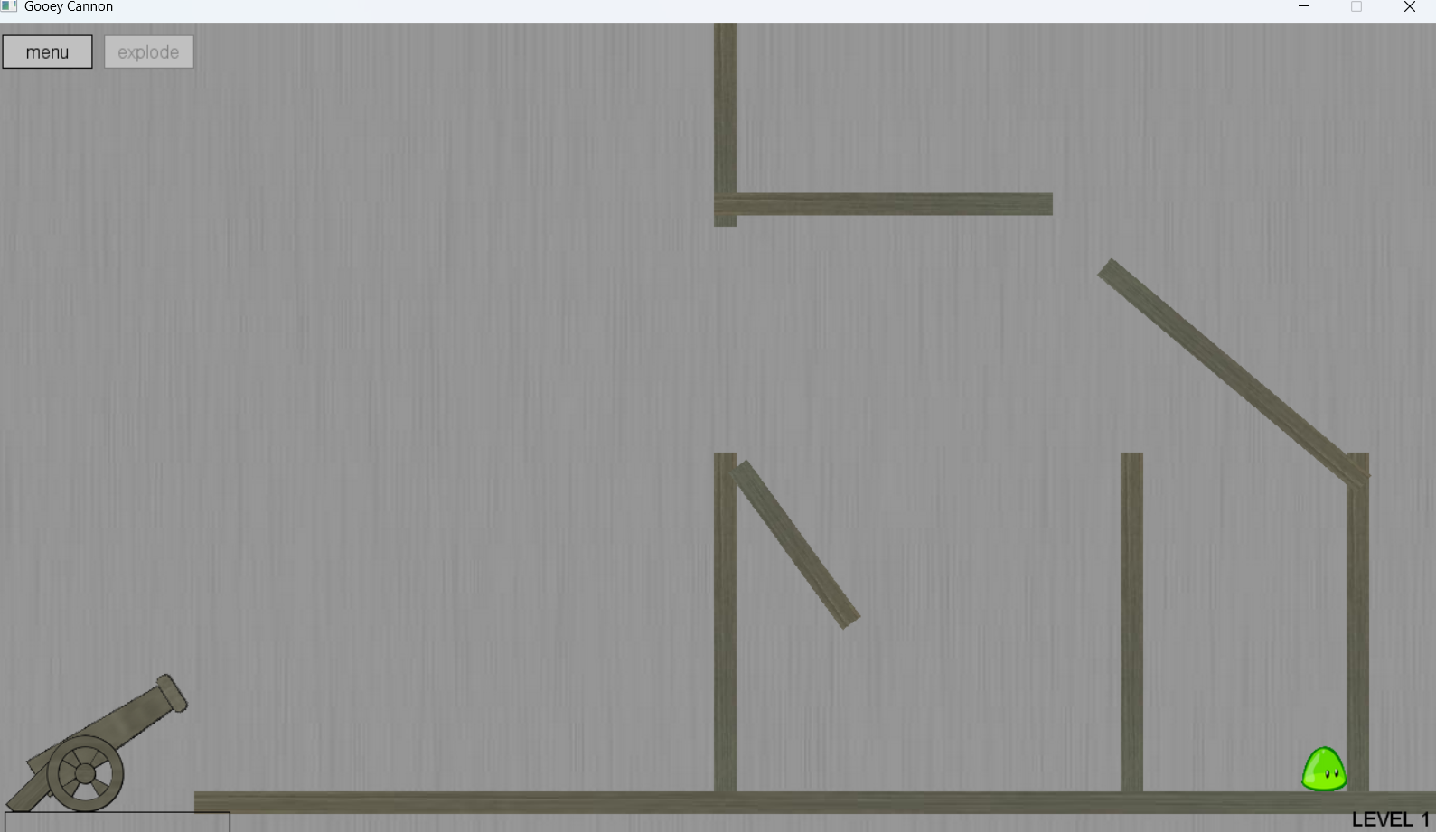

The idea is to bounce the ball off the top slope straight onto the slime